## Controlling Access with Role Based Access Control (RBAC)

### Lab Overview

In this lab, you will configure access to an Azure Resource Group using role based access control (RBAC).

### Exercise 1: Create user and group in Azure AD

We will be using the ‘Current’ portal experience to work with Azure Active Directory. Note that managing Azure AD in the current portal is **in Preview**. You can still use the ‘classic’ portal to manage Azure AD in a supported way.

1. Click on **More services**, and enter **Active Directory** in the search dialog. Then click **Azure Active Directory**.

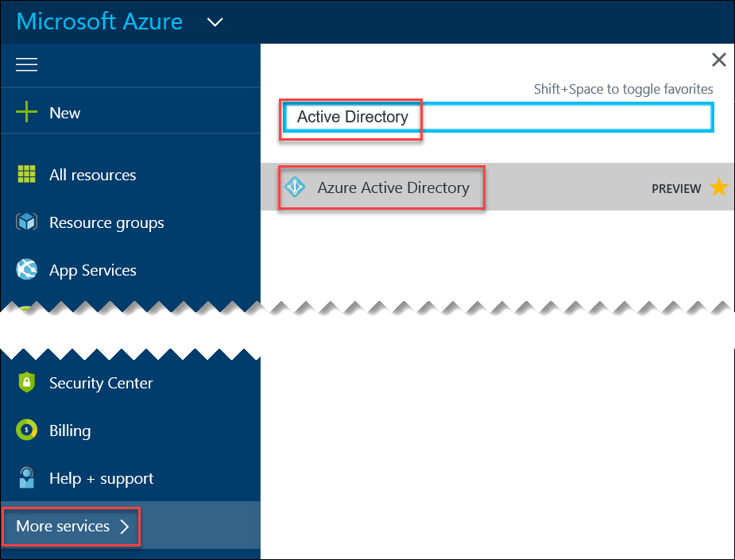

1. On the **Quick tasks** tile click **Add a user**.

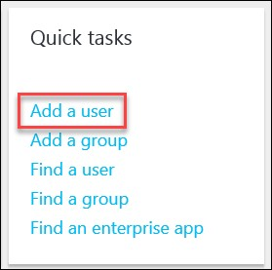

1. Enter the following, then click **Create**:
   1. Name: **VMAdmin**
   2. Username: vmadmin@[yourADTenant].onmicrosoft.com
   3. Check the box to **Show Password** then record this temporary password in **Notepad**.

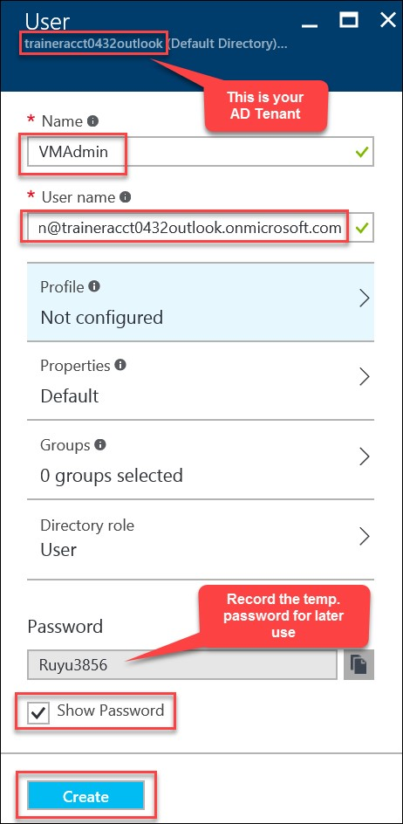

1. Back on the **Quick tasks** tile, click **Add a group**.

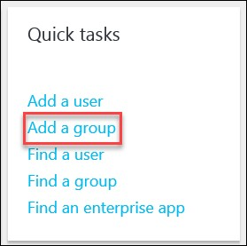

1. Enter the following:
   * 1. Name: **VMAdmins**
     2. Description: **Virtual machine administrators**
     3. Membership type: Choose **Assigned**
     4. Click **Members**, check the box beside **VMAdmin**, then click **Select** e. Click **Create**

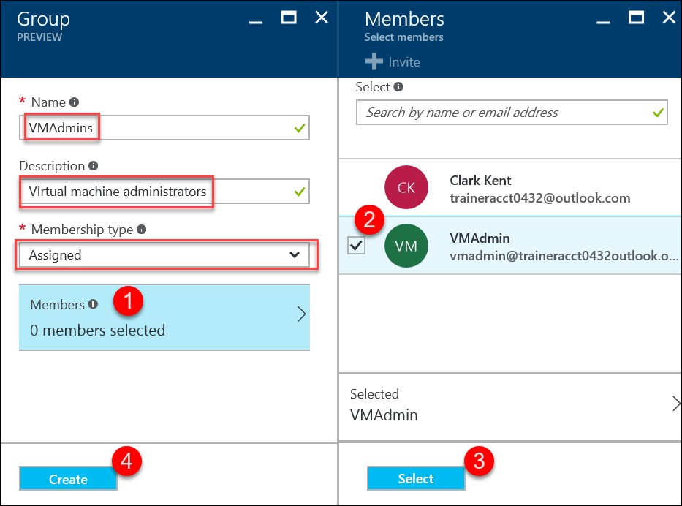

### Exercise 2: Add an Azure AD Group to a Resource Group

1. Open the Azure Portal (https://portal.azure.com), open the **WebVM-1** virtual machine created in the previous lab, go to **Access control (IAM)**.

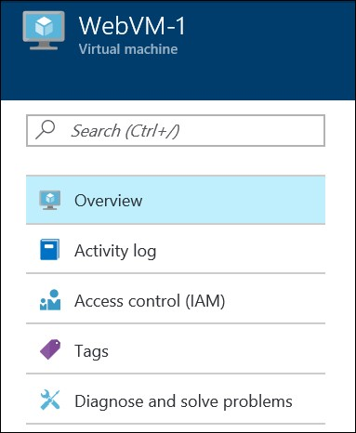

1. On the Users blade click **Add**.



1. This will open the **Add access** blade. Go to the **Select a role** blade and choose the **Owner** role.

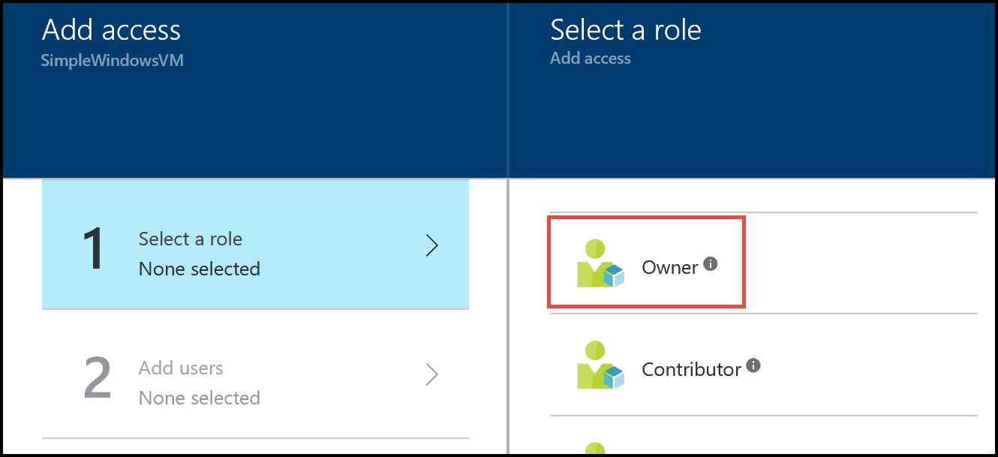

1. On the **Add users** blade type **VMAdmin** into the search bar, then choose the **vmadmin** user you created in the previous exercise then click the **Select** button, and click the **OK** button on the **Add access** blade to accept the changes.

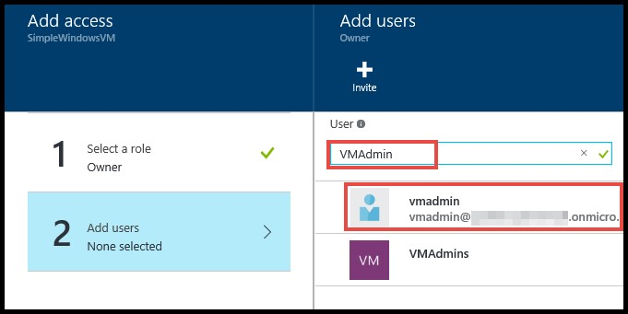

1. Open a new InPrivate browser window and navigate to the Azure Portal (https://portal.azure.com)

1. Use the login **vmadmin@<your subscription directory>.onmicrosoft.com** for the username and the temporary password you noted when you created the user.

1. On first login you will need to change the password. Change the password to **demo@pass123**.

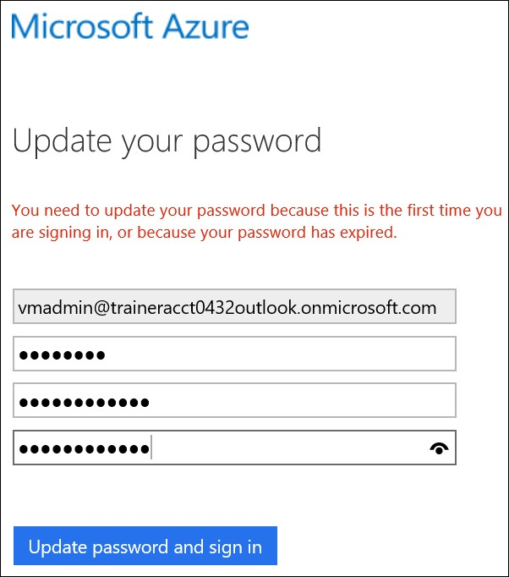

1. In the Azure Portal click on **All resources**. Notice that you only see the **WebVM-1** virtual machine resource. Click on the **WebVM-1** virtual machine resource.

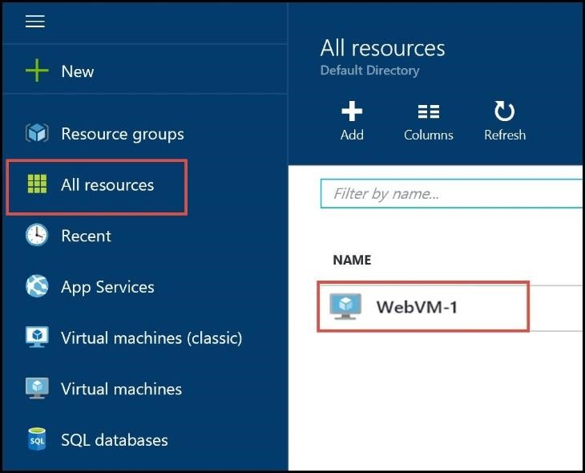

1. Click on **Network interfaces**, then click on the VM’s interface. Notice that you received an Access Denied message. What happened?

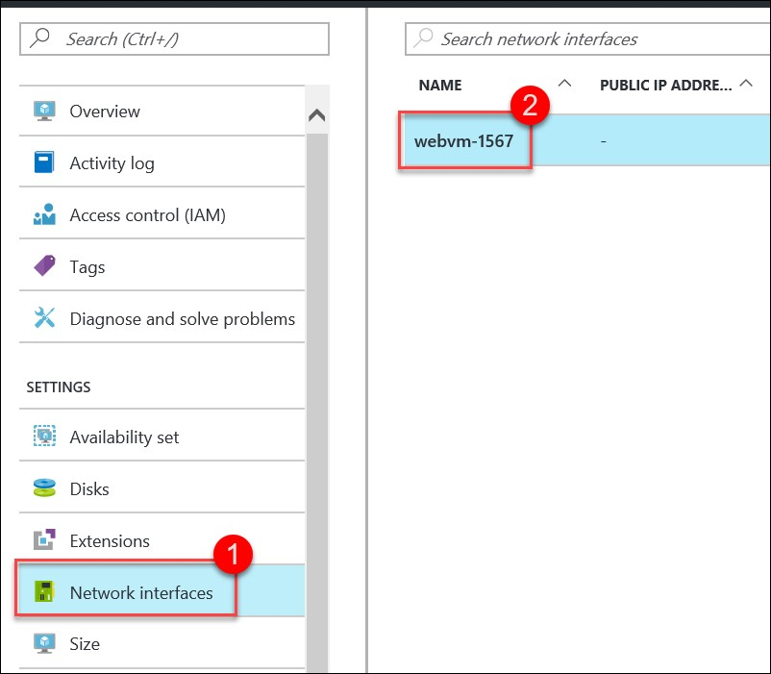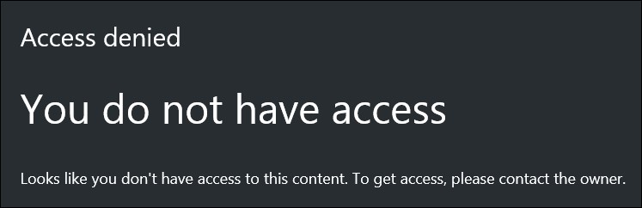

1. Accessing the configuration of a virtual machine requires accessing other resources such as NIC and IP Address resources. By only granting access to the virtual machine resource you have not granted sufficient privileges to view all the associated resources of the virtual machine. To resolve this, go back to your Azure portal session where you are logged on with full rights. Open the **OpsVMRmRG** resource group, click **Access control (IAM)**.

1. Click the **Add** button.



1. On the **Select a role** blade click **Owner**.

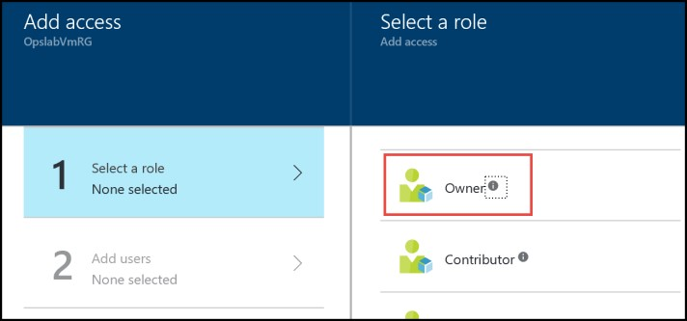

1. On the **Add users** blade type **VMAdmins** into the search bar, choose the **VMAdmins** group from the search results. Click the **Select** button, then click the **OK** button on the **Add access** blade to accept the changes.

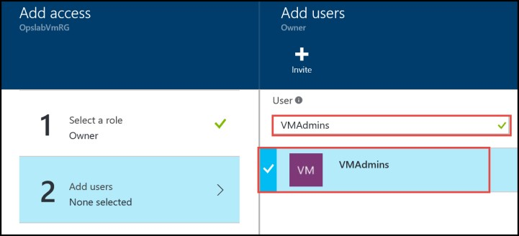

1. Open a new InPrivate browser window and login to the Azure Portal (https://portal.azure.com) using the **vmadmin@<your subscription directory>.onmicrosoft.com** login.

1. Click on **All resources**. You will now see all of the resources from the **OpsVMRmRG** resource group. Click on the **WebVM-1** virtual machine.

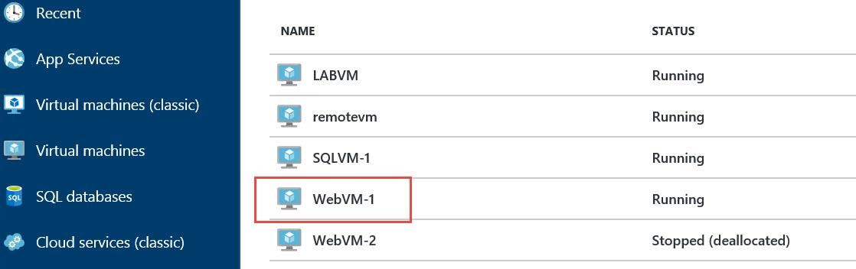

1. Notice that the **WebVM-1** virtual machine blade opens and that you are able to manage the network interface without error.

Lab Summary

In this lab, you configured access to an Azure Resource Group using role based access control (RBAC).